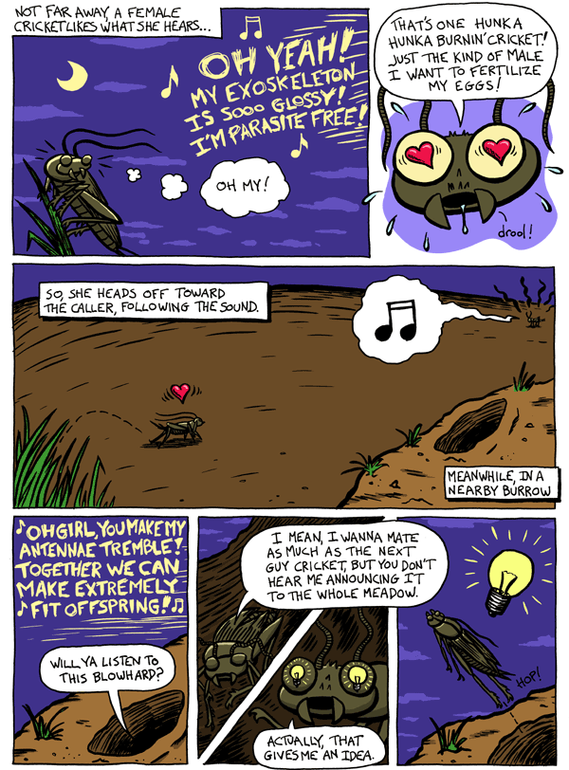

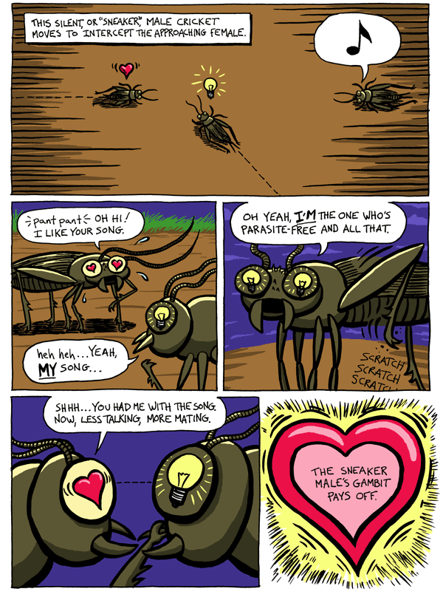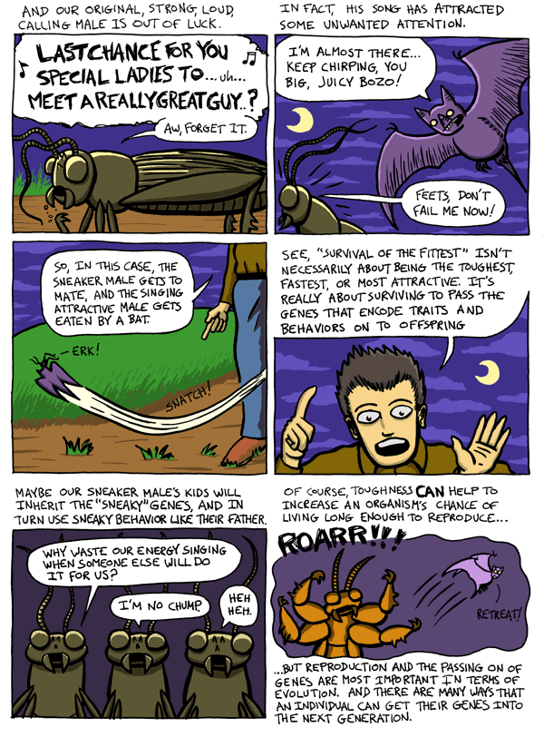

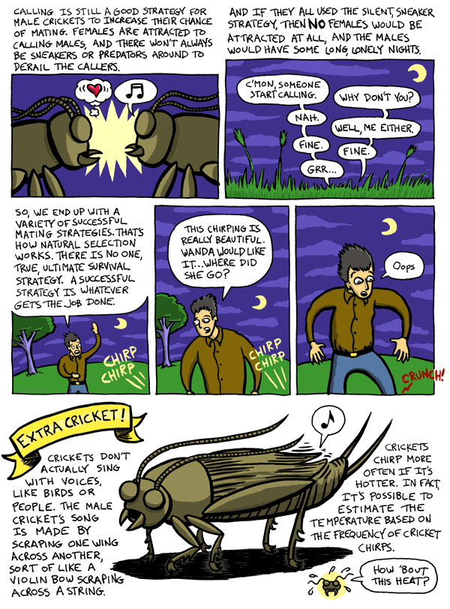

**Discussion questions**

**NAMES:_____________________________________**

1. When it comes to crickets, what does fitness mean?
2. Is calling good or bad for a cricket's fitness?
3. Give some examples of selection at work in this cricket story.
4. How does selection favor calling? How does selection favor not calling?